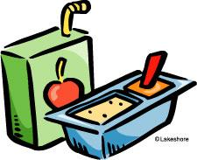Snack Time

Dear Families,

Each morning we will be having a brief snack time in our classroom around 10:45. If possible, please try to send in a healthy, nutritious snack for your child to eat at that time. In the past, students have brought in an apple, pretzel sticks, Ziploc bags of cereal, or even just half of a peanut butter sandwich. If you have any questions or concerns, please feel free to contact me at 735-2065 ext. 4100. Thank you for your help!

Sincerely,
Mrs. Monaco

